Activity diagram:

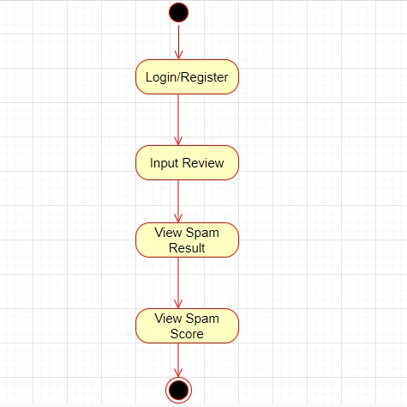

Class diagram

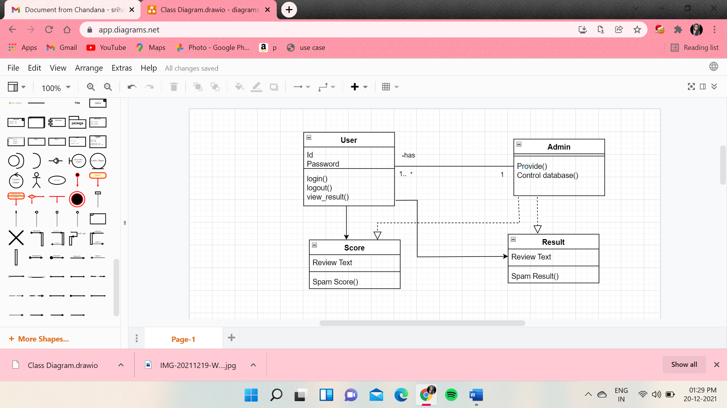

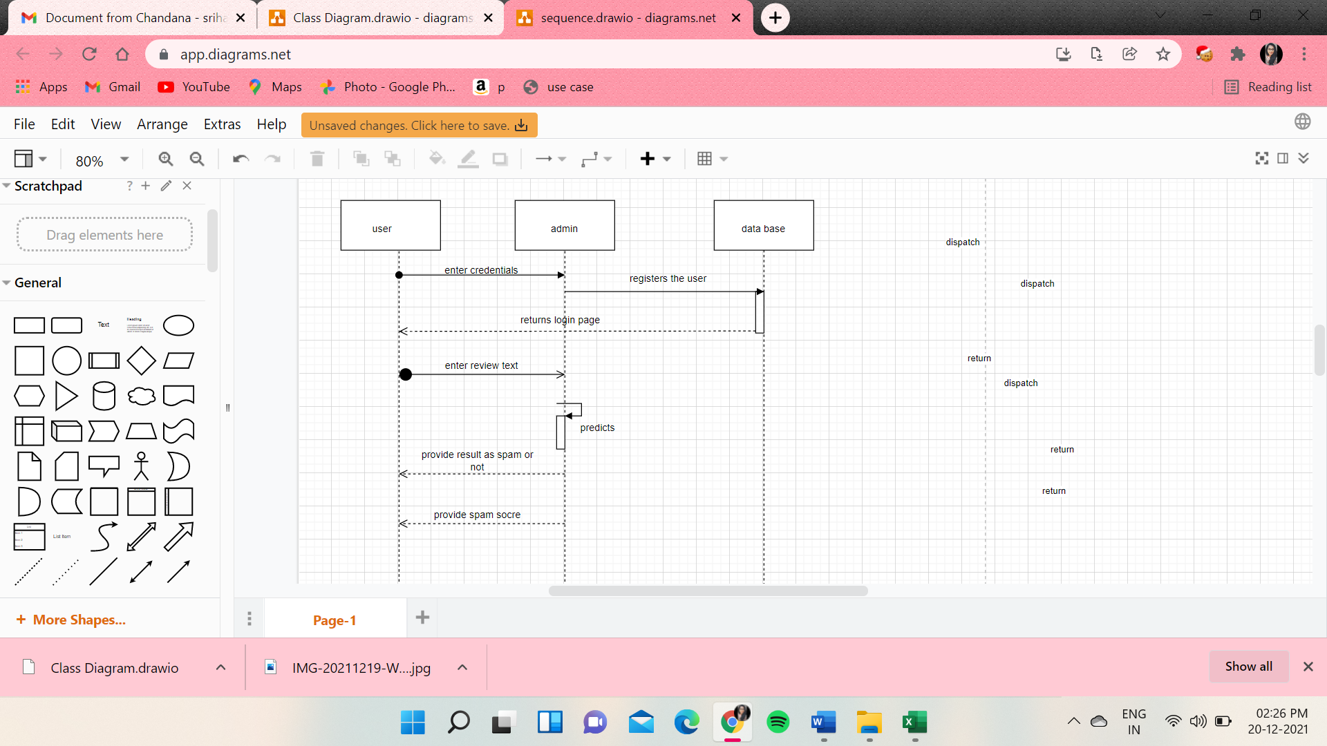Sequence diagram:

Data base description:

Our dataset is of size 40,433. Data set consists of 4 attributes namely

Category, Rating, Label, Review Text.

Attribute description:

1.Category : various types of products are categorized into the following types .They are

* Clothing_shoes and jewels,
* Toys and games
* Kindle store
* Books
* Pet supplies
* Movies and TV
* Sports and outdoors
* Home and kitchen
* Electronics
* Tools and Home improvements

2.Rating : It takes a numeric value ranging between 1 to 5.

3.Label : whole dataset is divided into two classes labelling CG(computer generated fake review)

OR(Original Review)

4.Text : Review text in the dataset.